[**https://utexas.instructure.com/courses/1243932/files/folder/Competitive%20Evaluations%20_%20Analysis?preview=48696086**](https://utexas.instructure.com/courses/1243932/files/folder/Competitive%20Evaluations%20_%20Analysis?preview=48696086)

**Goals**

* Users need to identify their chemical sensitivity
  + Efficient, effective, and satisfactory
* Users need to complete the form(s) efficiently
  + *Efficiently - the extent to which users can achieve their task goals, measures the degree of accuracy and/or completion*
* Users need to complete the form(s) effectively
  + *Effectively - measures resources used to perform task*
* Users need to complete the form(s) with feeling satisfaction
  + *Satisfaction - Measures the affective reaction (likes, dislikes, attitudinal response) of users to the application/resource*
* Help identify health problems you may be having and to understand your responses to various exposures.
* Task as defined by Qessi: make it easy to use, to share the results, also make it more valid, more consistent in the result finding
* Current problems: A lot of reading, people confused, lack of feedback

Link to connect you with doctor

Ability to save

Comparing results from week to week

Create an account - look at how others are doing this

**Competitors**

**Direct Competitors**

**WebMD**: <https://symptoms.webmd.com/default.htm#/info>

*Background*

Online symptom checker, which allows users input their symptom and give them possible conditions and corresponding treatment.

*Good points*

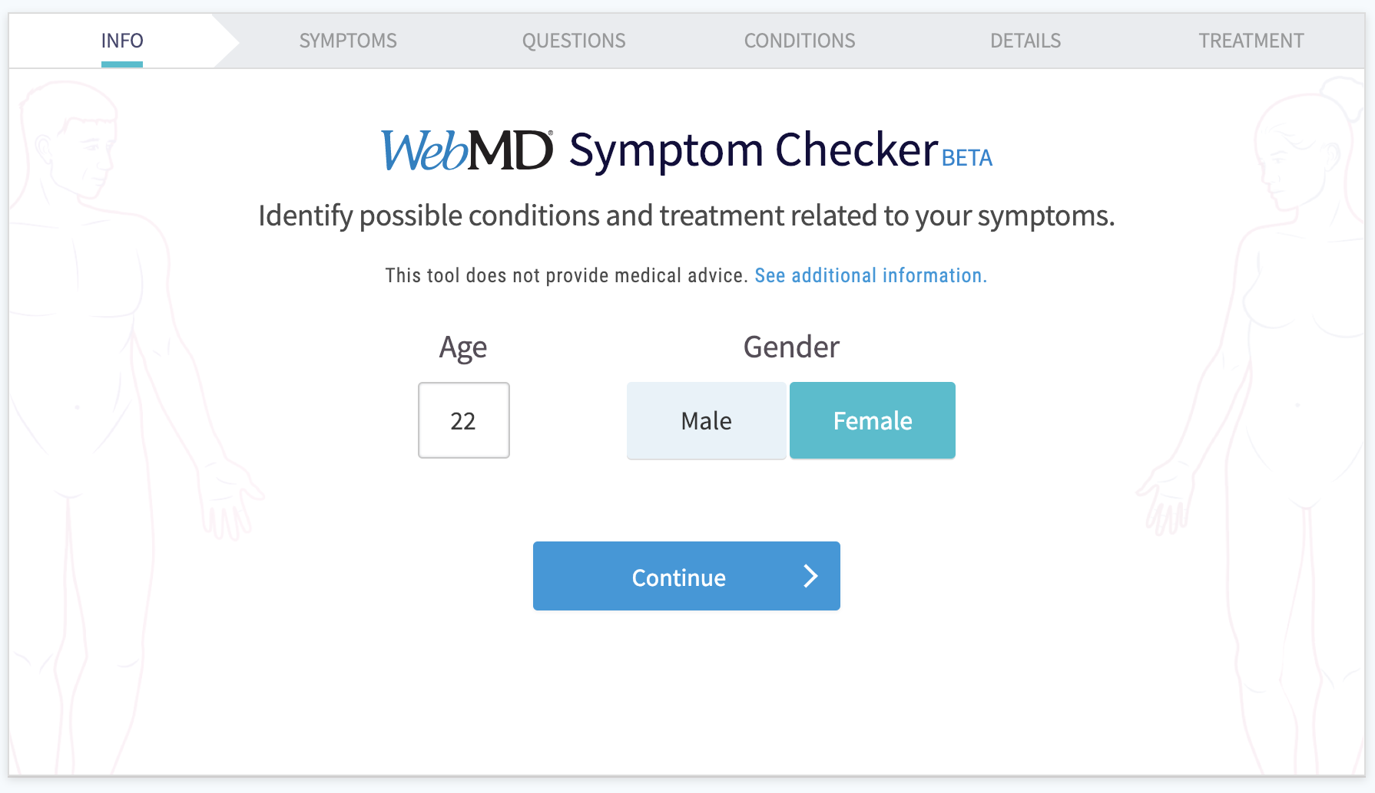

1. Using Wizard instead of long Form

Unlike Quessi, which uses a long form to let users complete. WebMD uses a wizard to guide untrained users to achieve their goals through a series of steps. The user can enter data in each view and proceeds to the next step until completion.

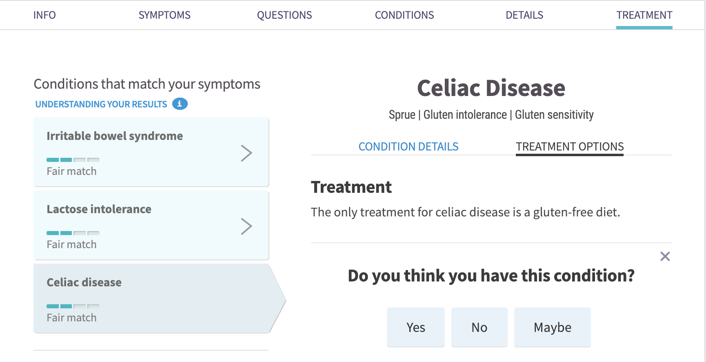

2. Asking for feedback

When showing users with different possible conditions, it will ask users for their feedback. This can create a conversation feeling for users.

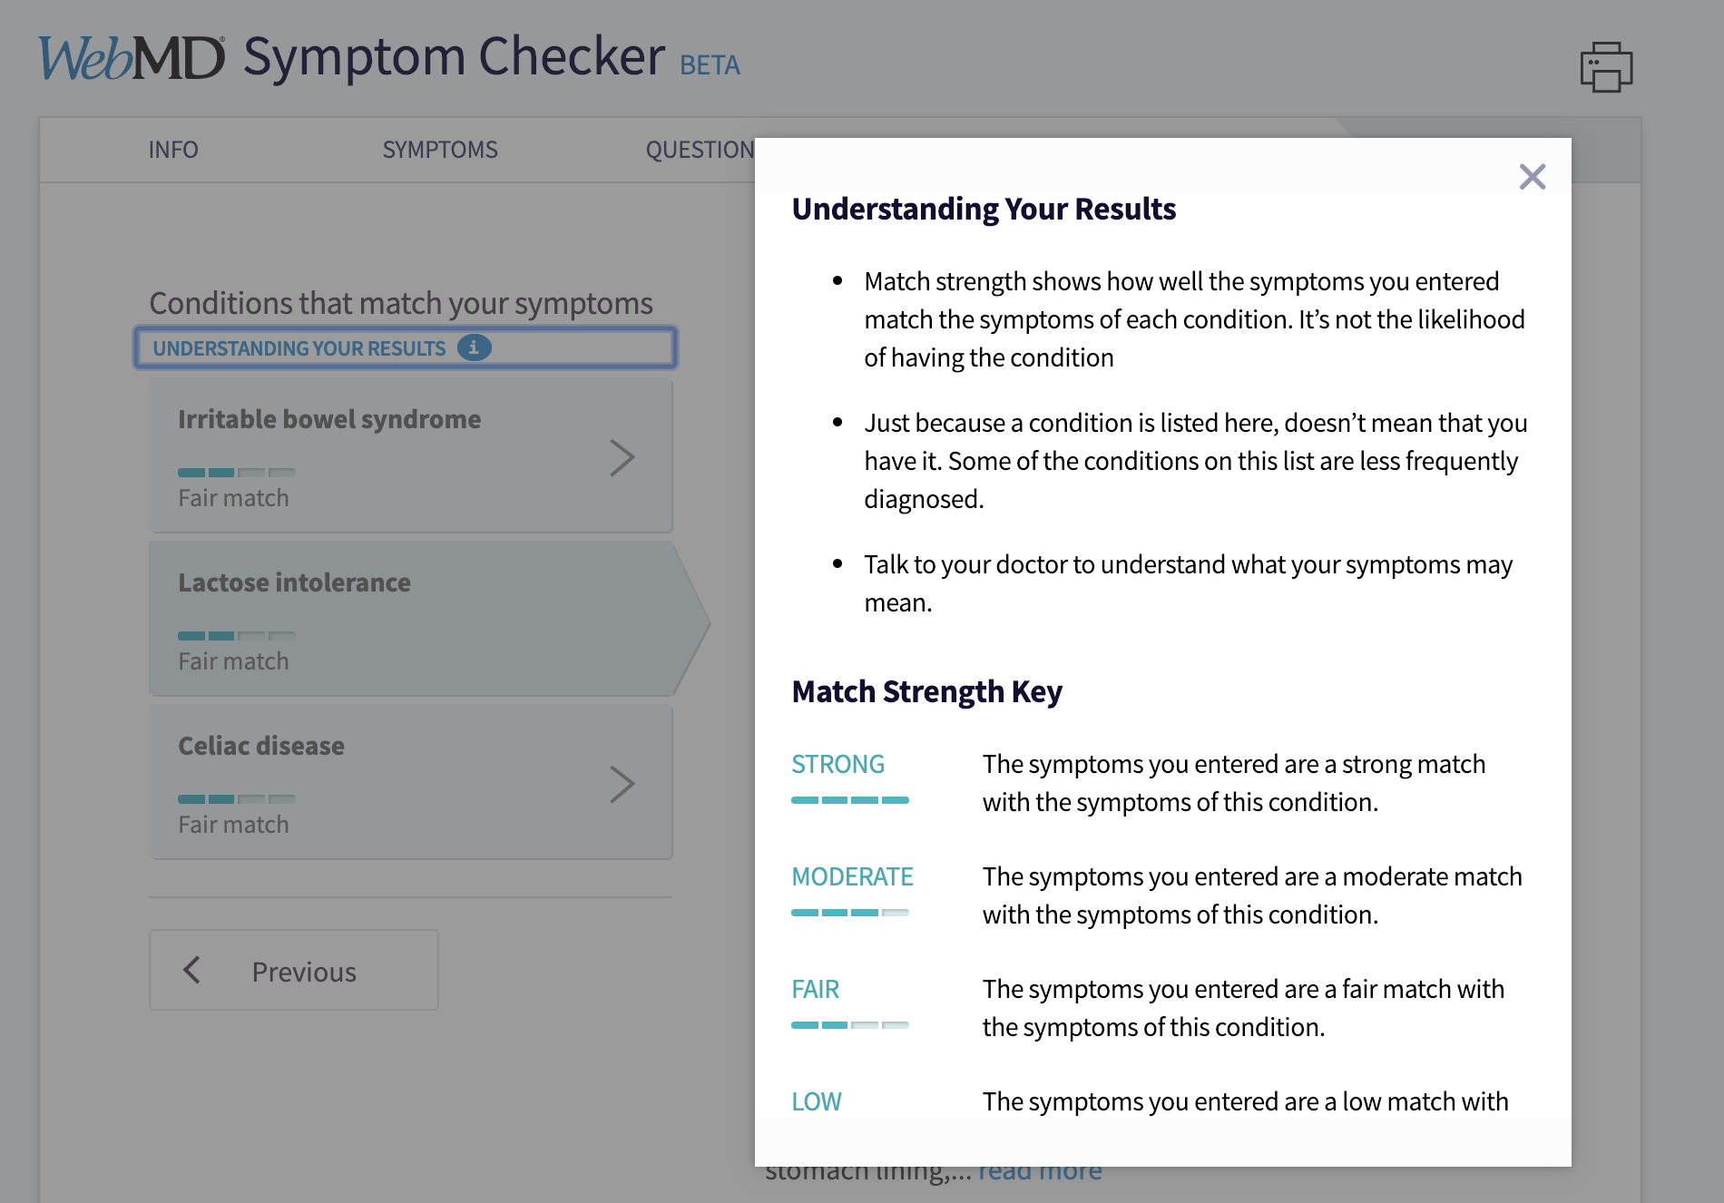

3. Explanation

WebMD offers an explanation for the results and can reduce users‘ confusion to it.

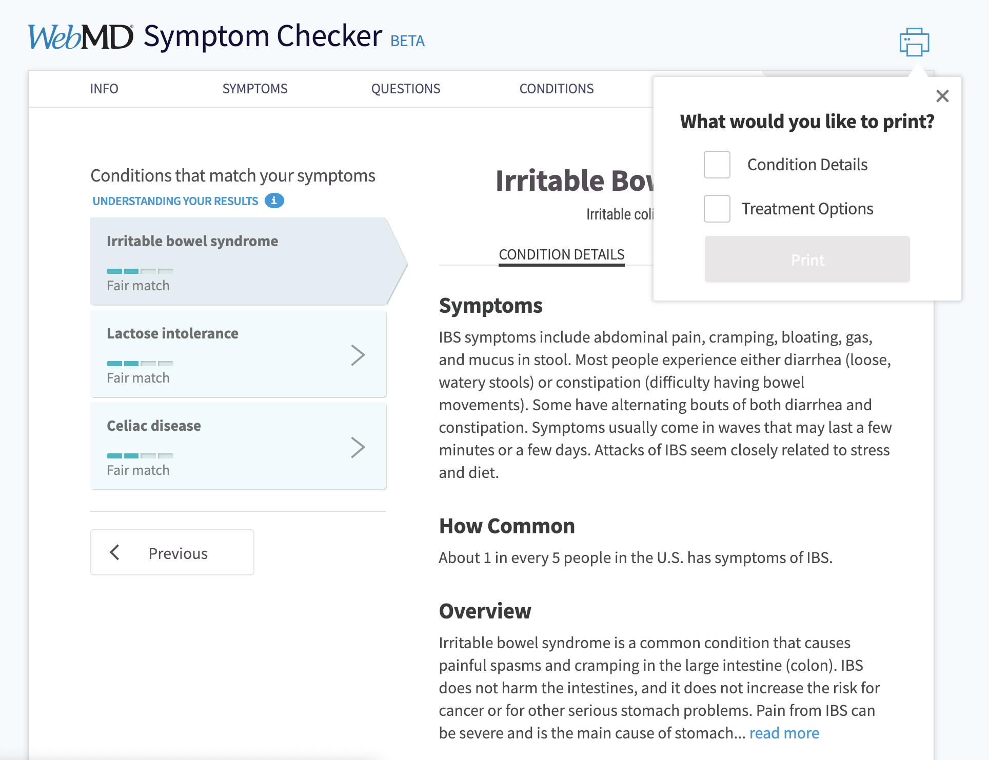

4. More print options

One problem we found in heuristic evaluation of Qessi is that it can only print the whole form and not customized the part users want. In WebMD, it offers different print options, users can choose which part they want to print.

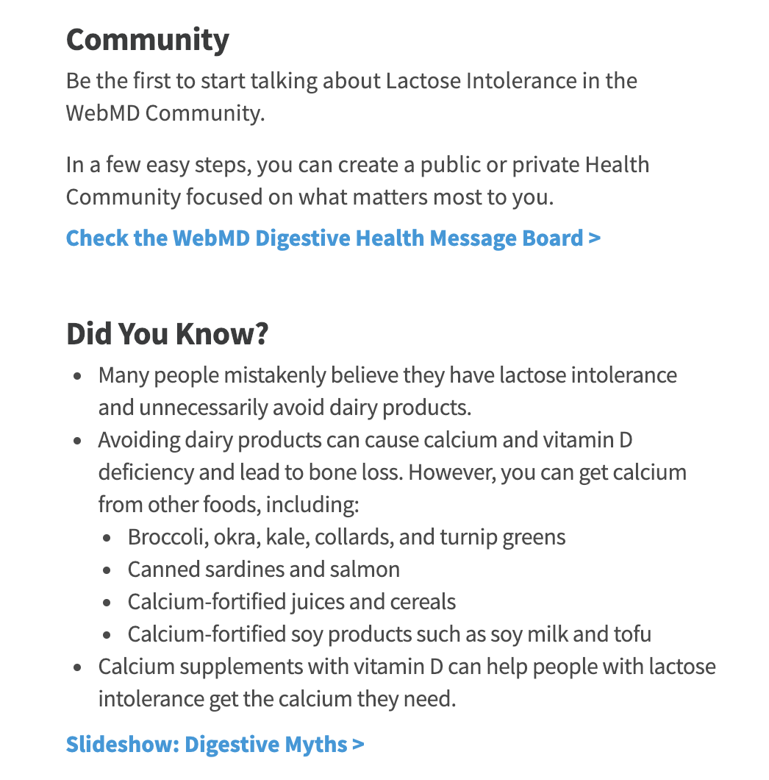

4. Additional Support

WebMD has its own community, which gives users a channel to talk about symptom. Also, it can continuously attract users to go back to the website and update their situation.

Slideshow links to an article introducing relevant condition they users may want to know.

*Bad points*

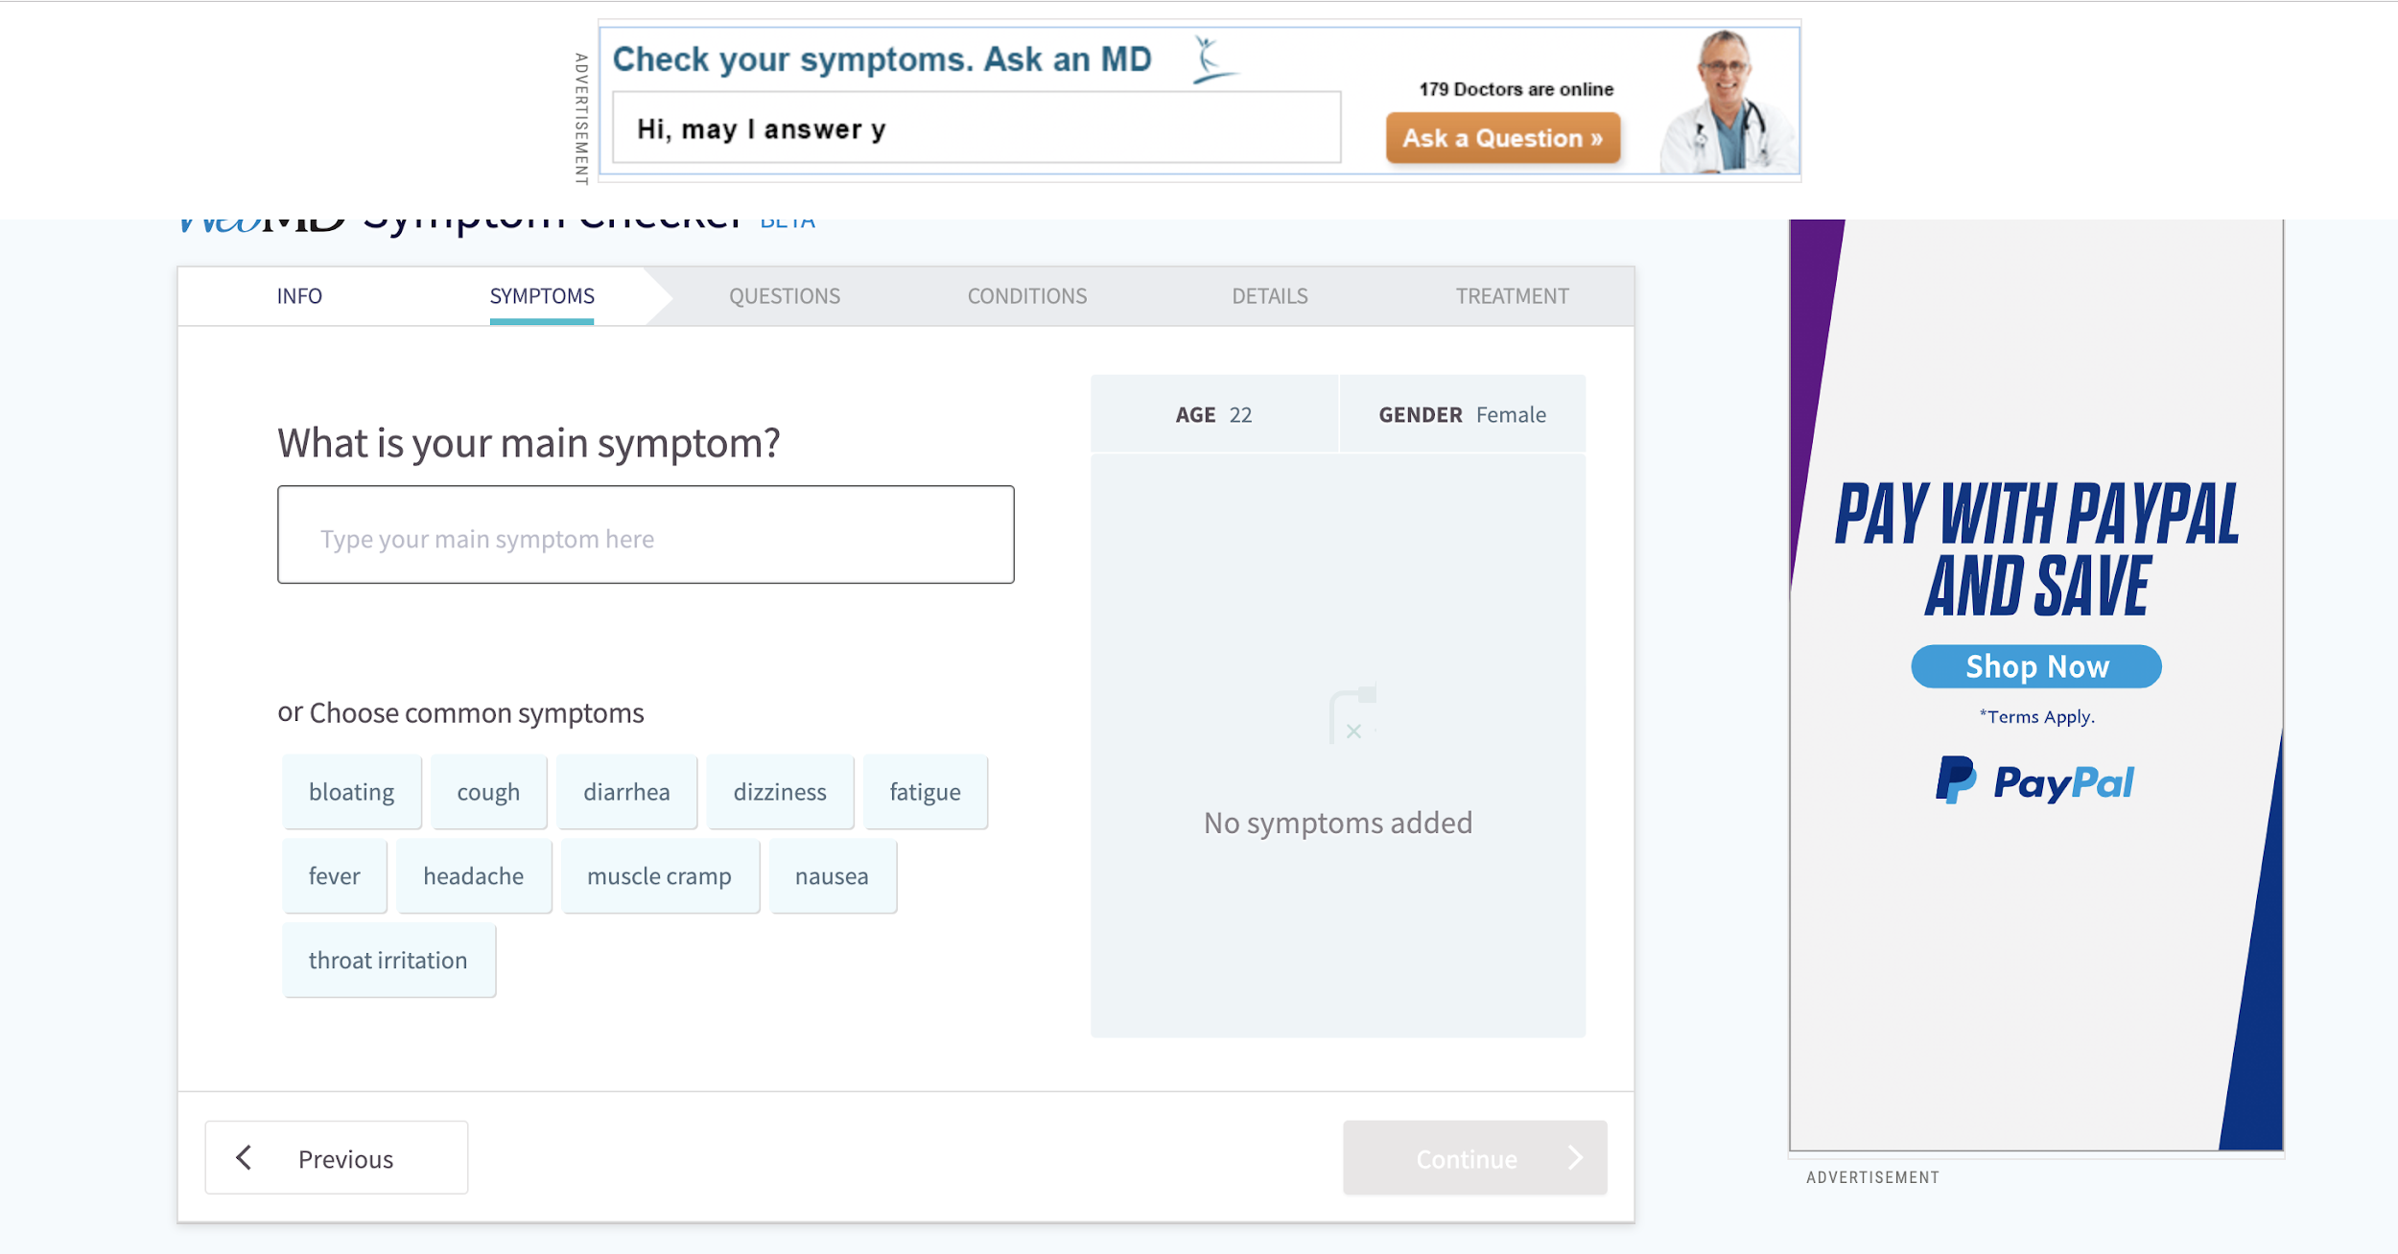

Too many attracting ads disturbing users complete the task.

**Mayo Clinic:** [**https://www.mayoclinic.org/symptom-checker/select-symptom/itt-20009075**](https://www.mayoclinic.org/symptom-checker/select-symptom/itt-20009075)

*Background*

An online symptom checker

*Good point*

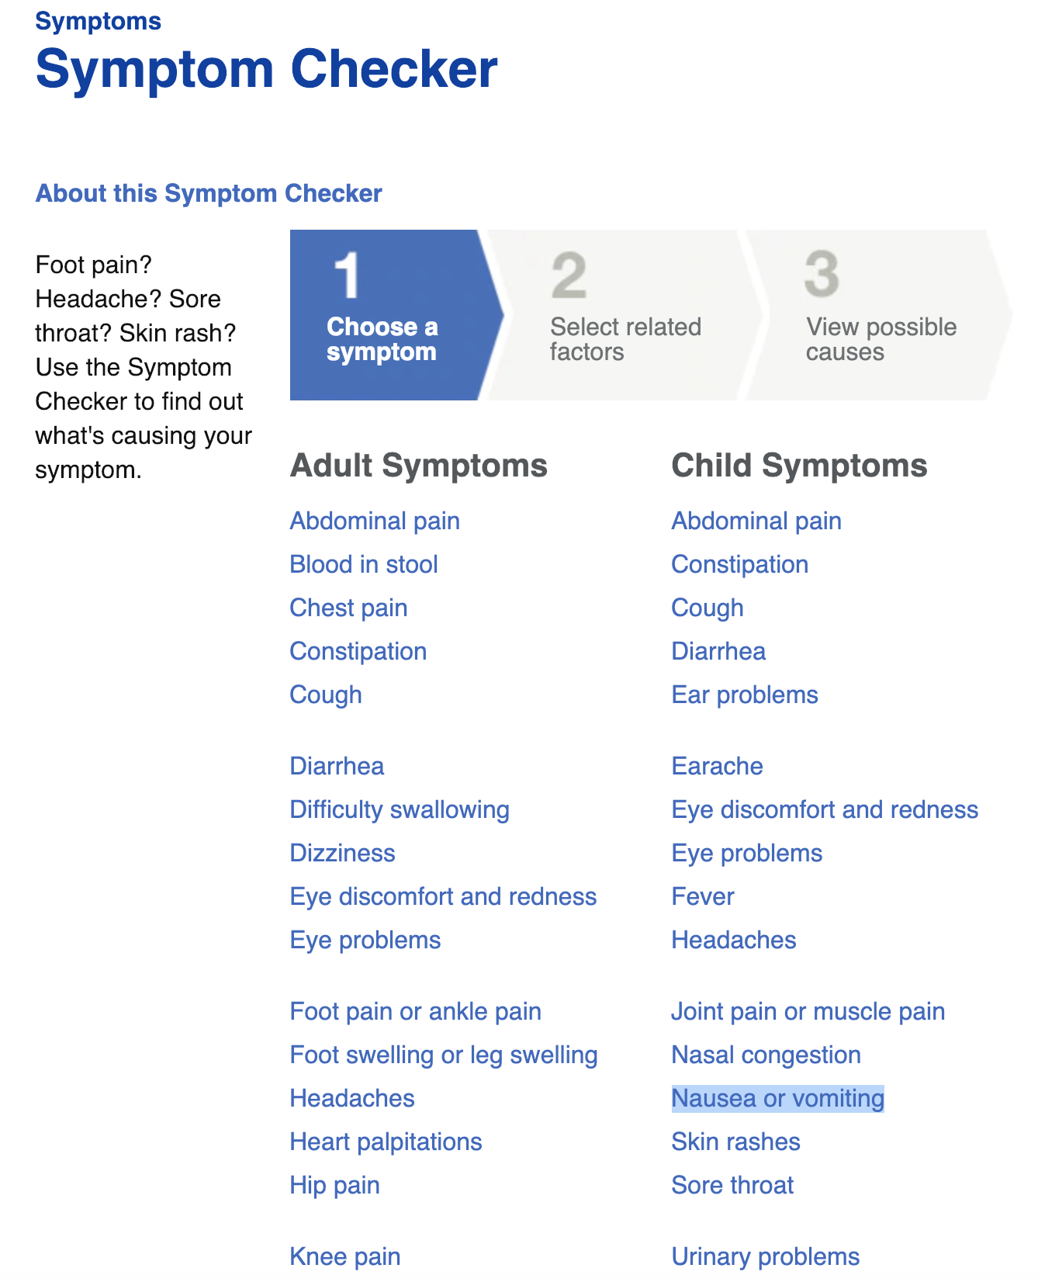

Has different categories for adult and child

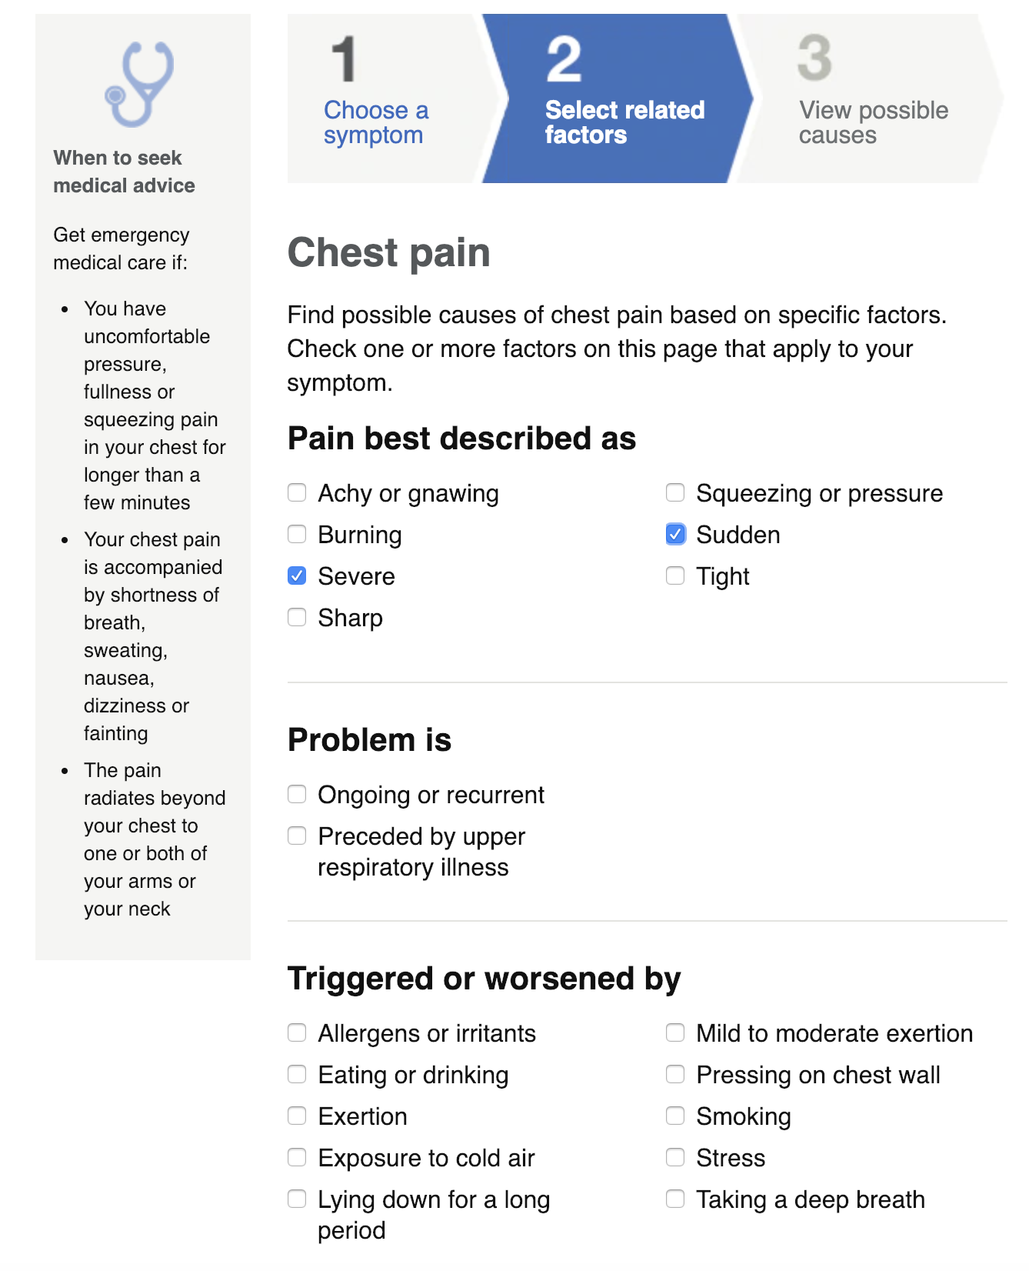

Using checkbox to provide more options

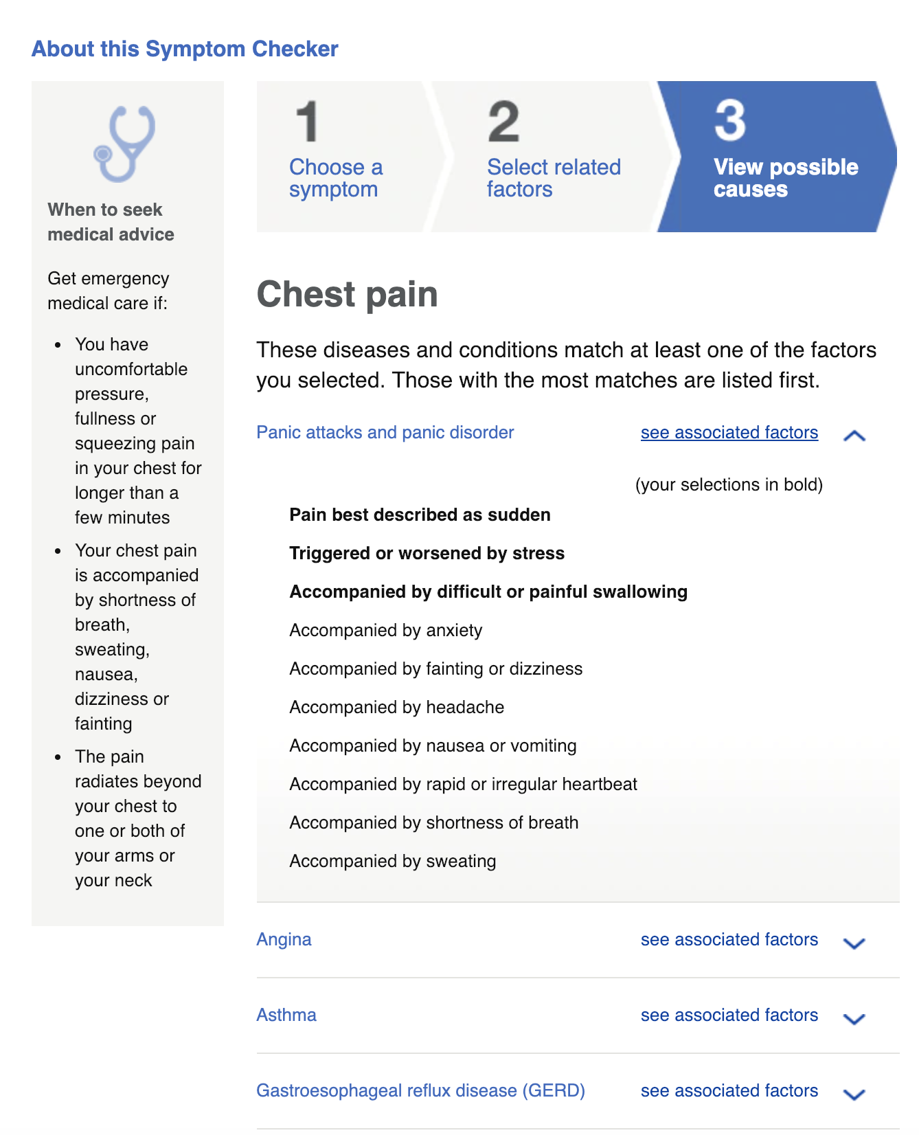

Listing diseases and conditions according to relevance.

Highlighting previous selections.

**Psychology Today**: <https://www.psychologytoday.com/us/tests/health/depression-test>

*Background*

An online depression test, verified by Psychology Today.

*Good point*

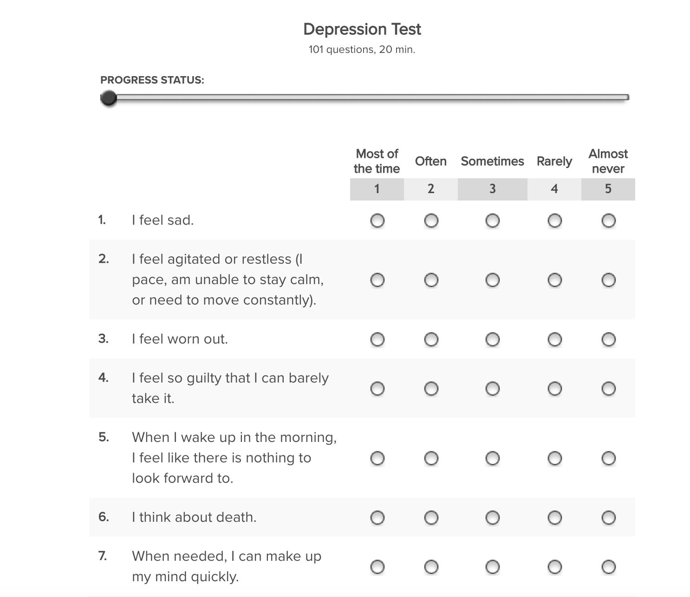

It tells users how many questions and how much time the test will take.

It has progress status.

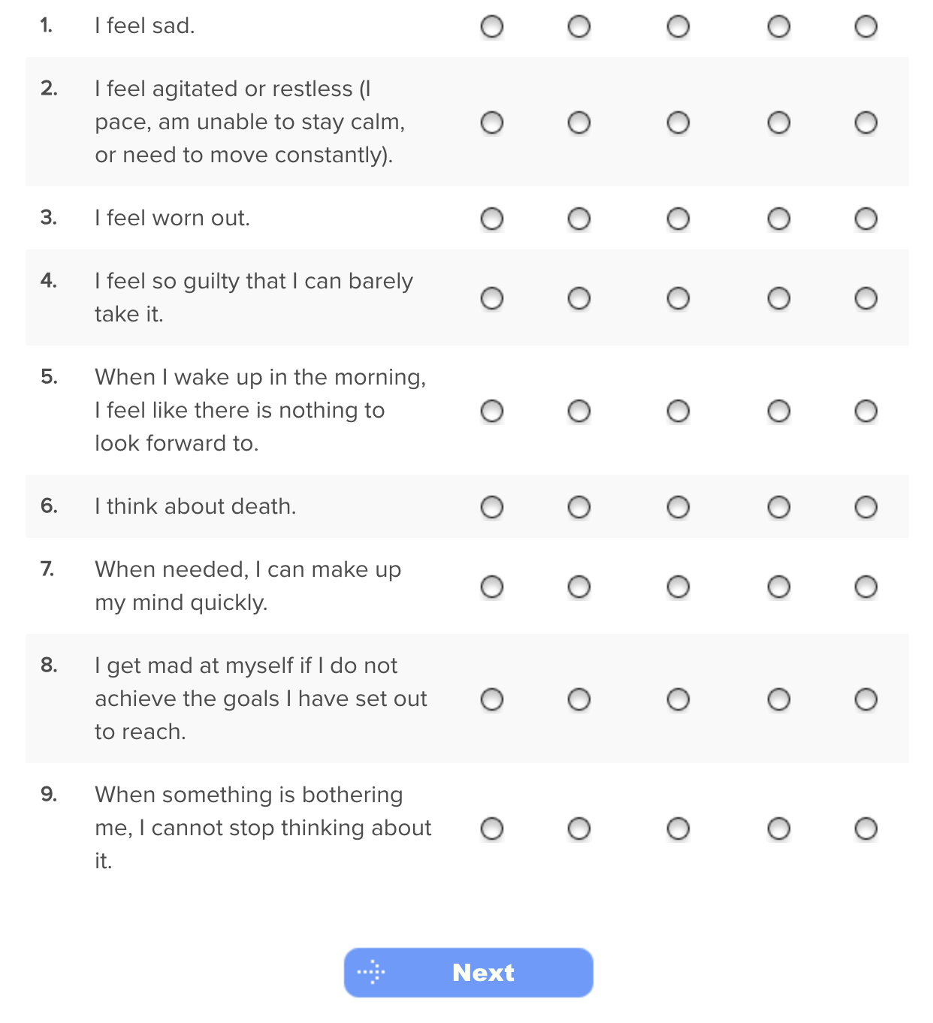

Dividing long questionnaire into several pages.

*Bad point*

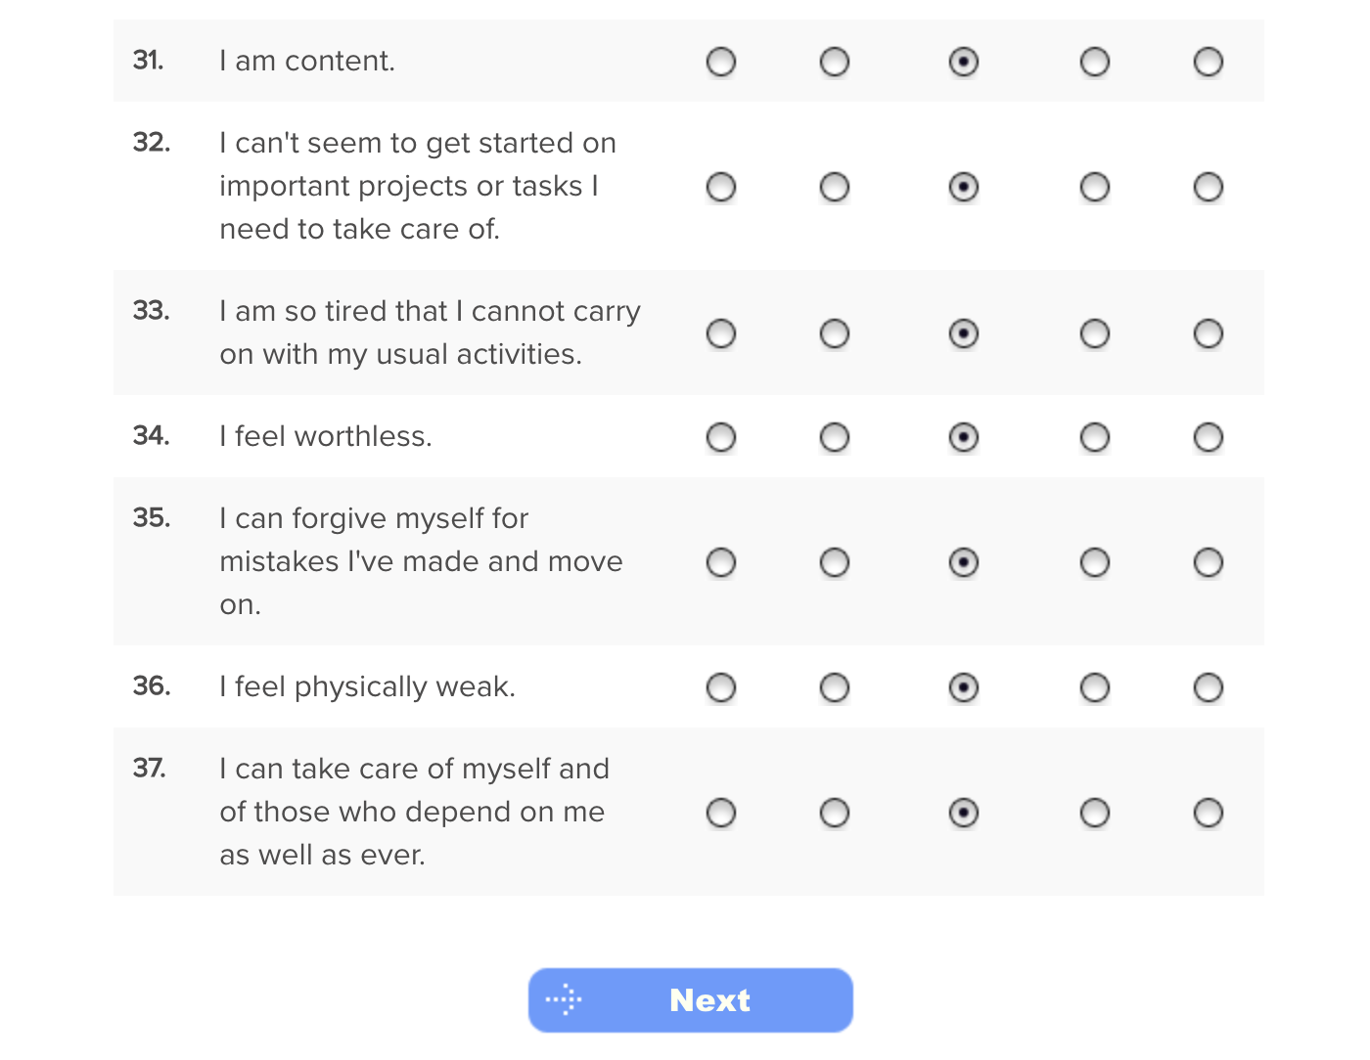

Cannot go back to see/change previous answers.

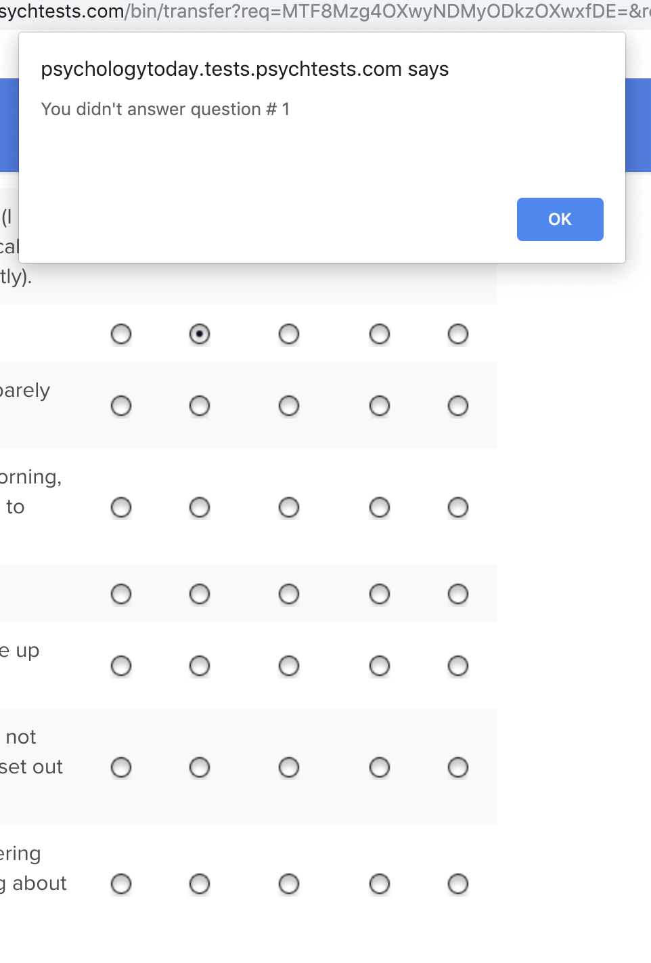

Must answer every question one by one.

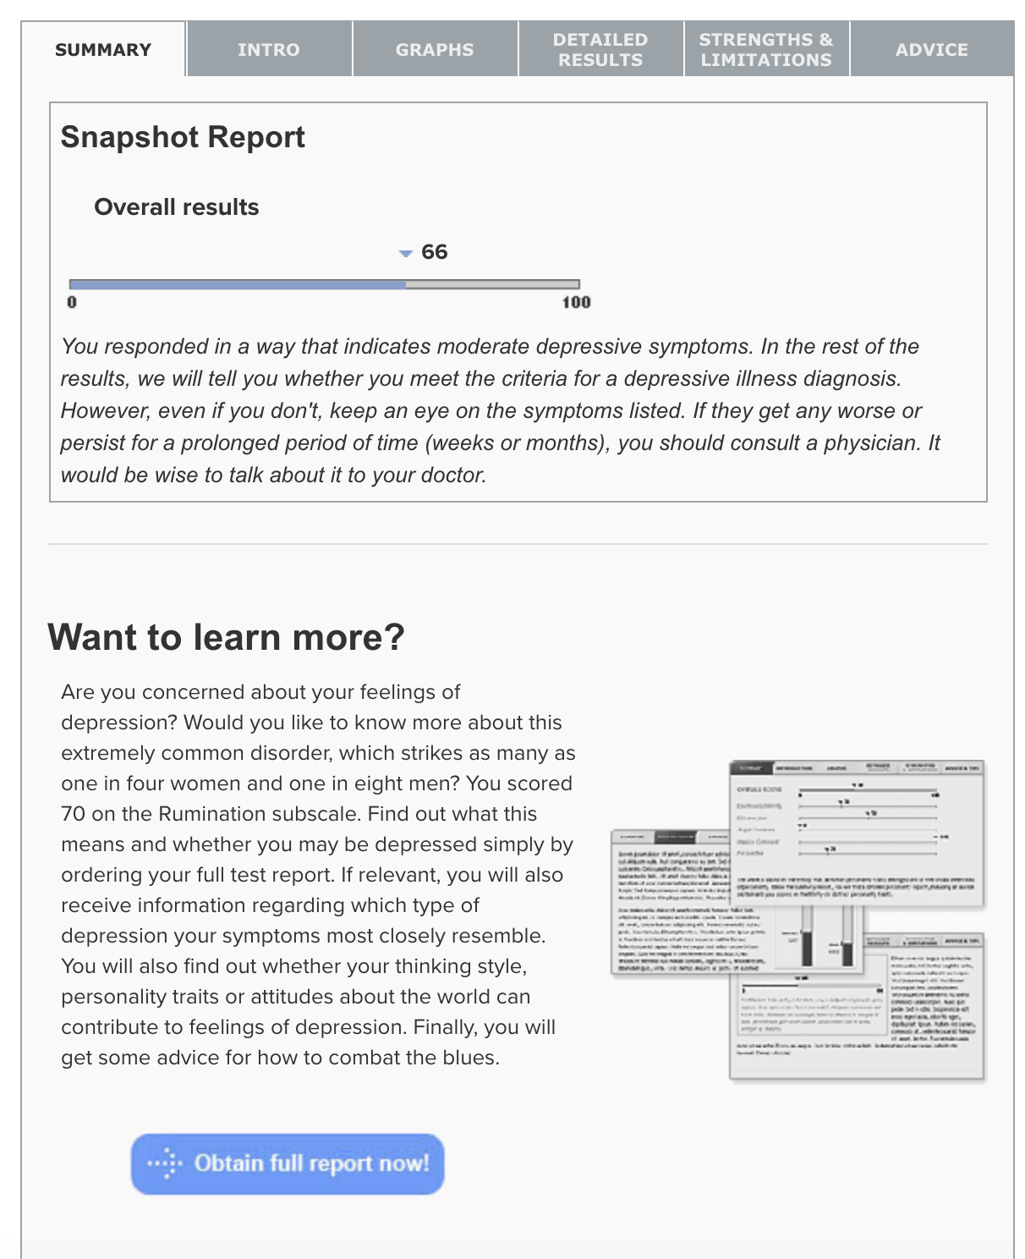

The results are incomplete.

**Indirect Competitors**

Because Qeesi expressed they wanted their survey to be approachable, we also looked at indirect competitors.

**Google Forms**

*Background*

Google Forms is a tool that allows collecting information from users via a personalized survey or quiz. The information is then collected and automatically connected to a spreadsheet. The spreadsheet is populated with the survey and quiz responses.

*Observations*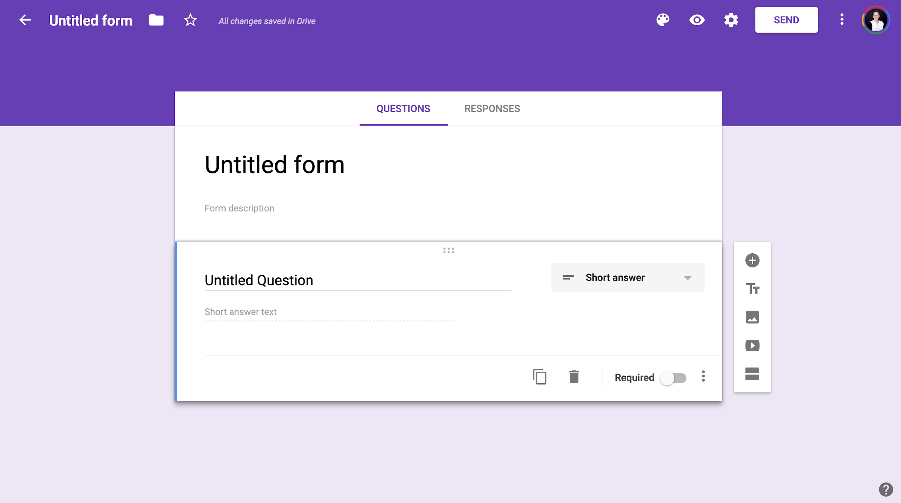

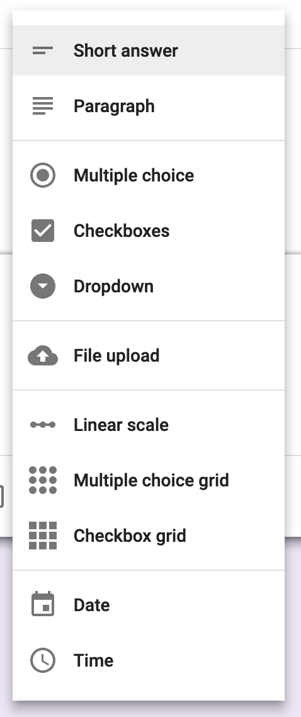

For creating a form, clean interface with the ability to change question type. Types of questions include: short answer, paragraph, multiple choice, checkboxes, dropdown, file upload, linear scale, multiple choice grid, checkbox grid, date, and time. User has ability to duplicate the question and choose whether it is a required response.

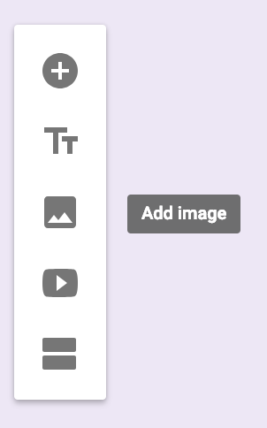

When creating, user also has ability to add images (upload from computer, snapshot from webcab, URL, Google Drive, Google search), videos, and separate questionnaire into titled sections.

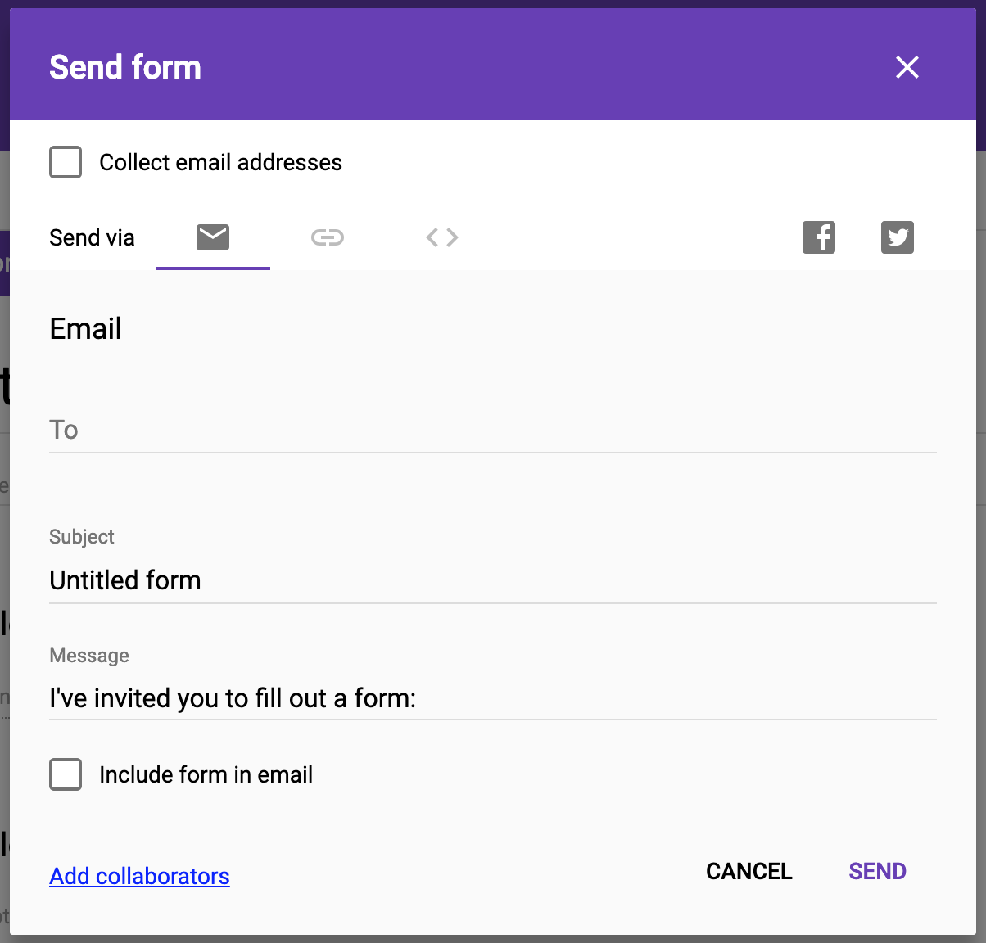

Questionnaire can be sent via email, shared as a link, directly to social media (Facebook or Twitter), or embedded HTML.

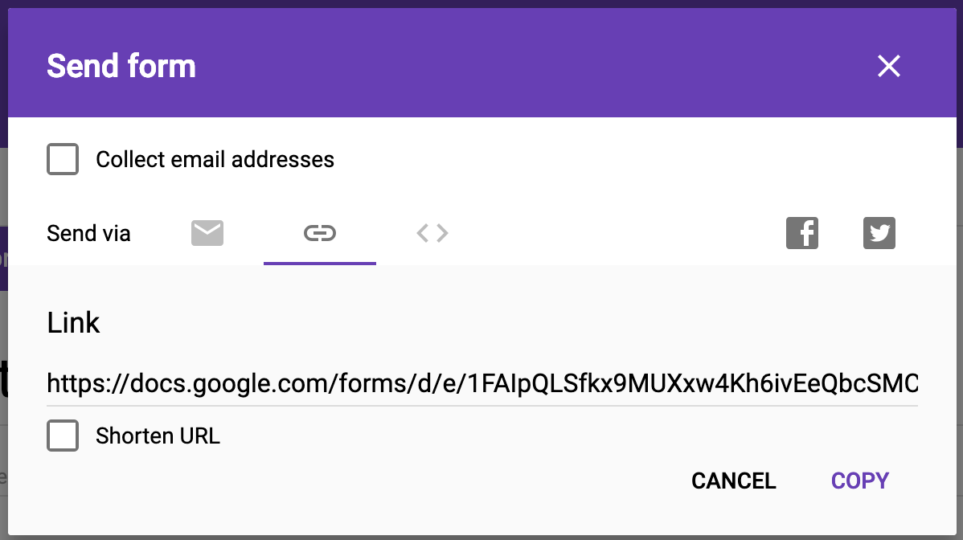

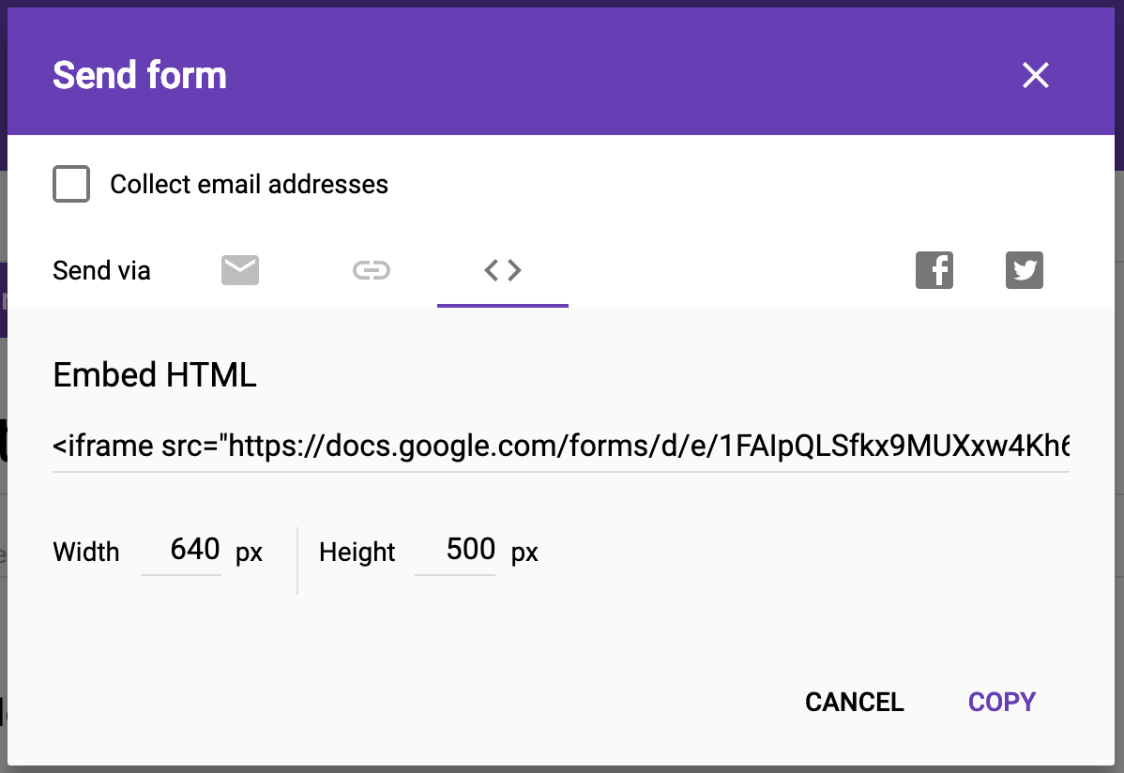

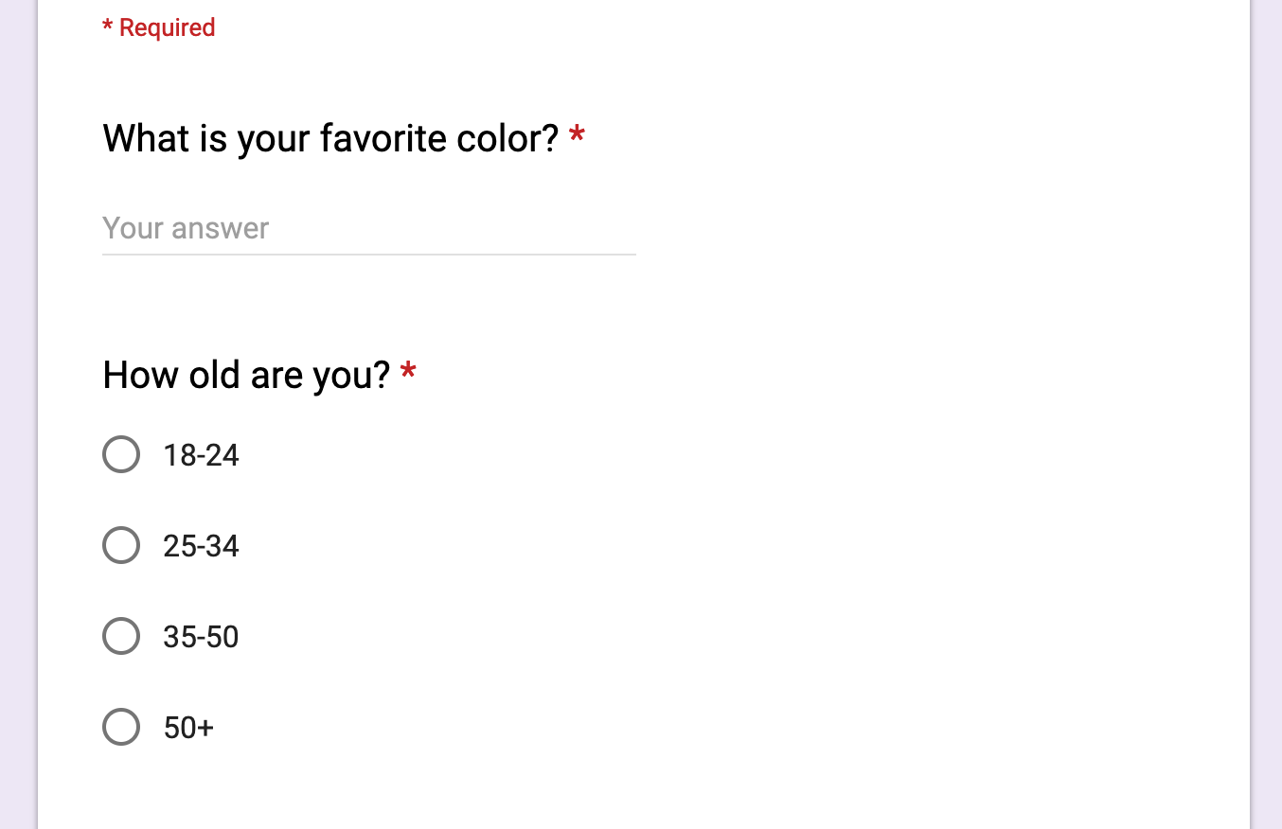

Required responses are indicated at the top with “*Required” in red text and an asterisk next to each required question.

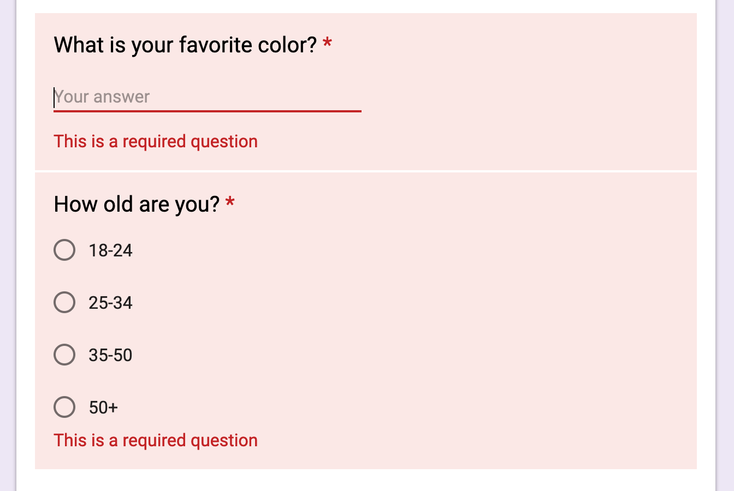

When attempting to skip a required response, the area highlights in pink with “This is a required question” in red text.

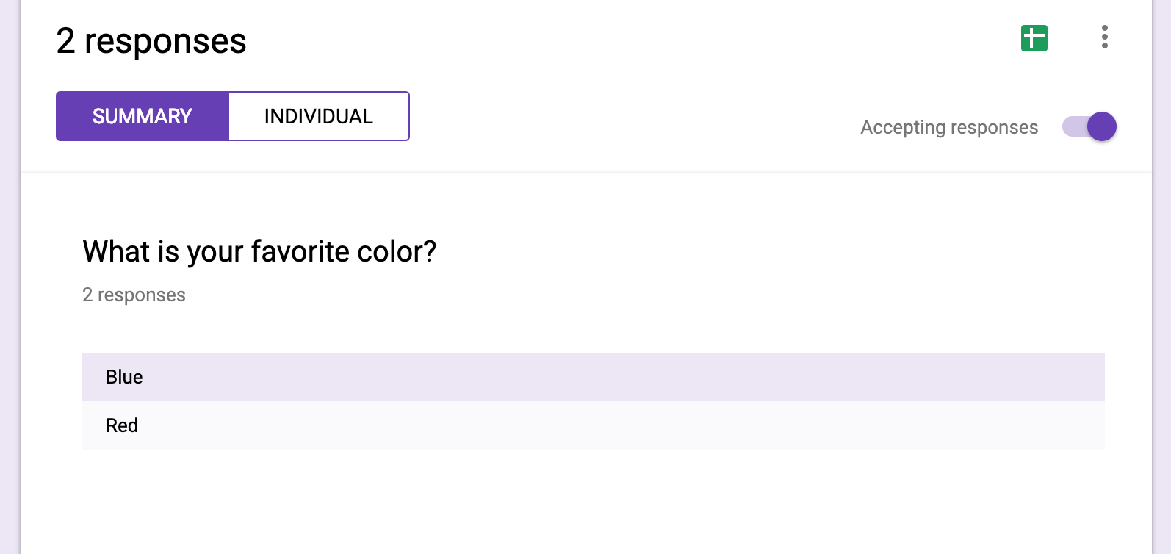

Can view responses in “Summary” or “Individual” view.

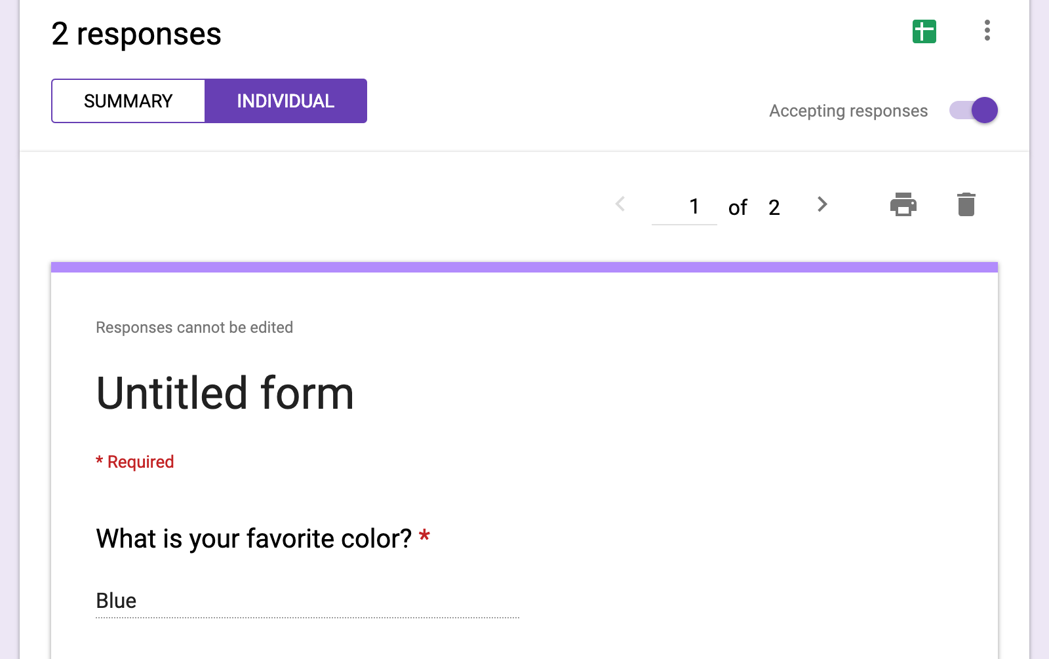

Ability to export data to Google Sheets (where further data visualization can be created).

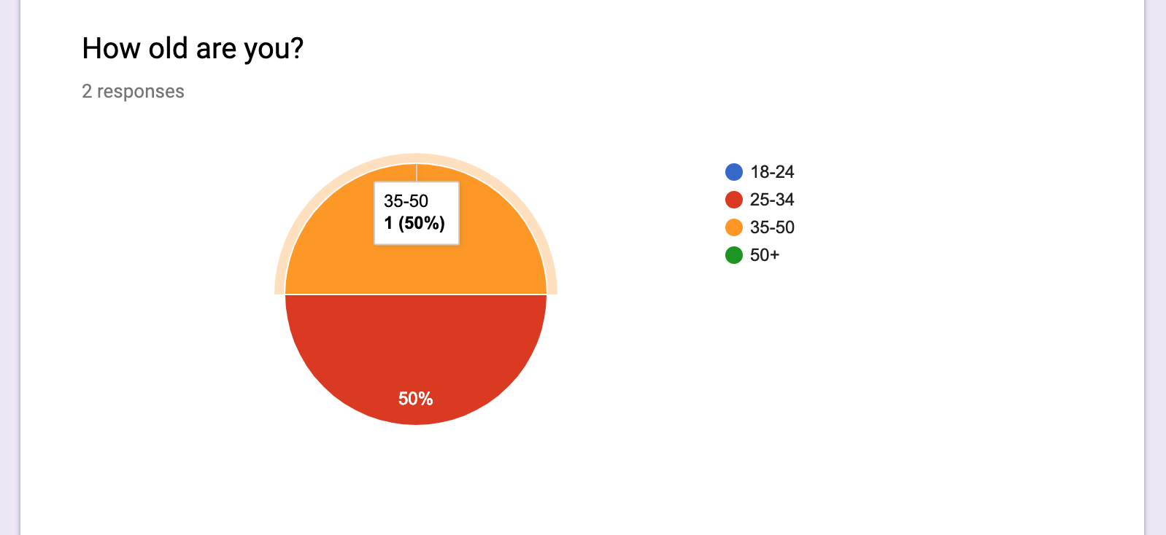

Data visualization for some response-types within Google Forms.

**16 Personalities**

*Background*

Fun and engaging approach for taking the Myers-Briggs Personality Test.

*Observations*

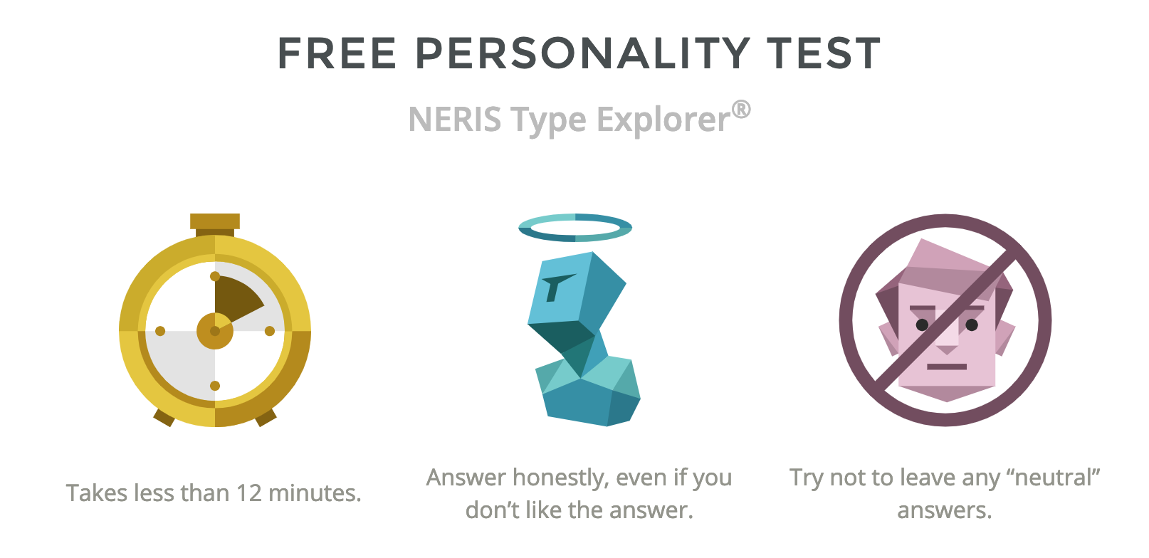

Simply, visual information presented before taking the test for how to answer.

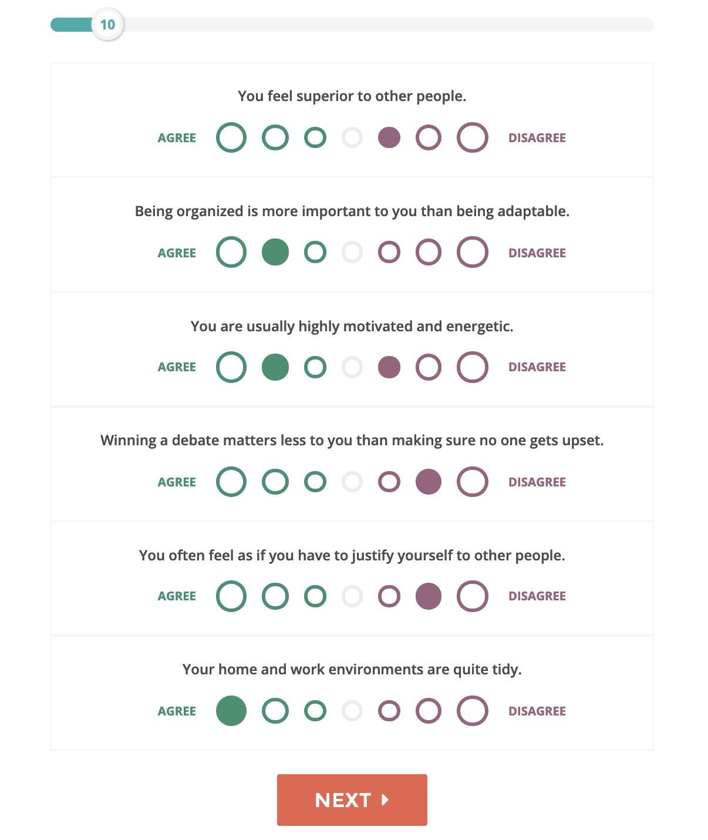

Progress bar at the top in increments of 10 per page. Six questions per page; 60 questions total.

Color and size used to help distinguish scale; green = agree, purple = disagree. Do color and size bias the responses?

Can skip questions. None of them are “required” and therefore there’s no feedback for skipping questions.

No way to edit previous answers. Is this as important for something like this personality test?

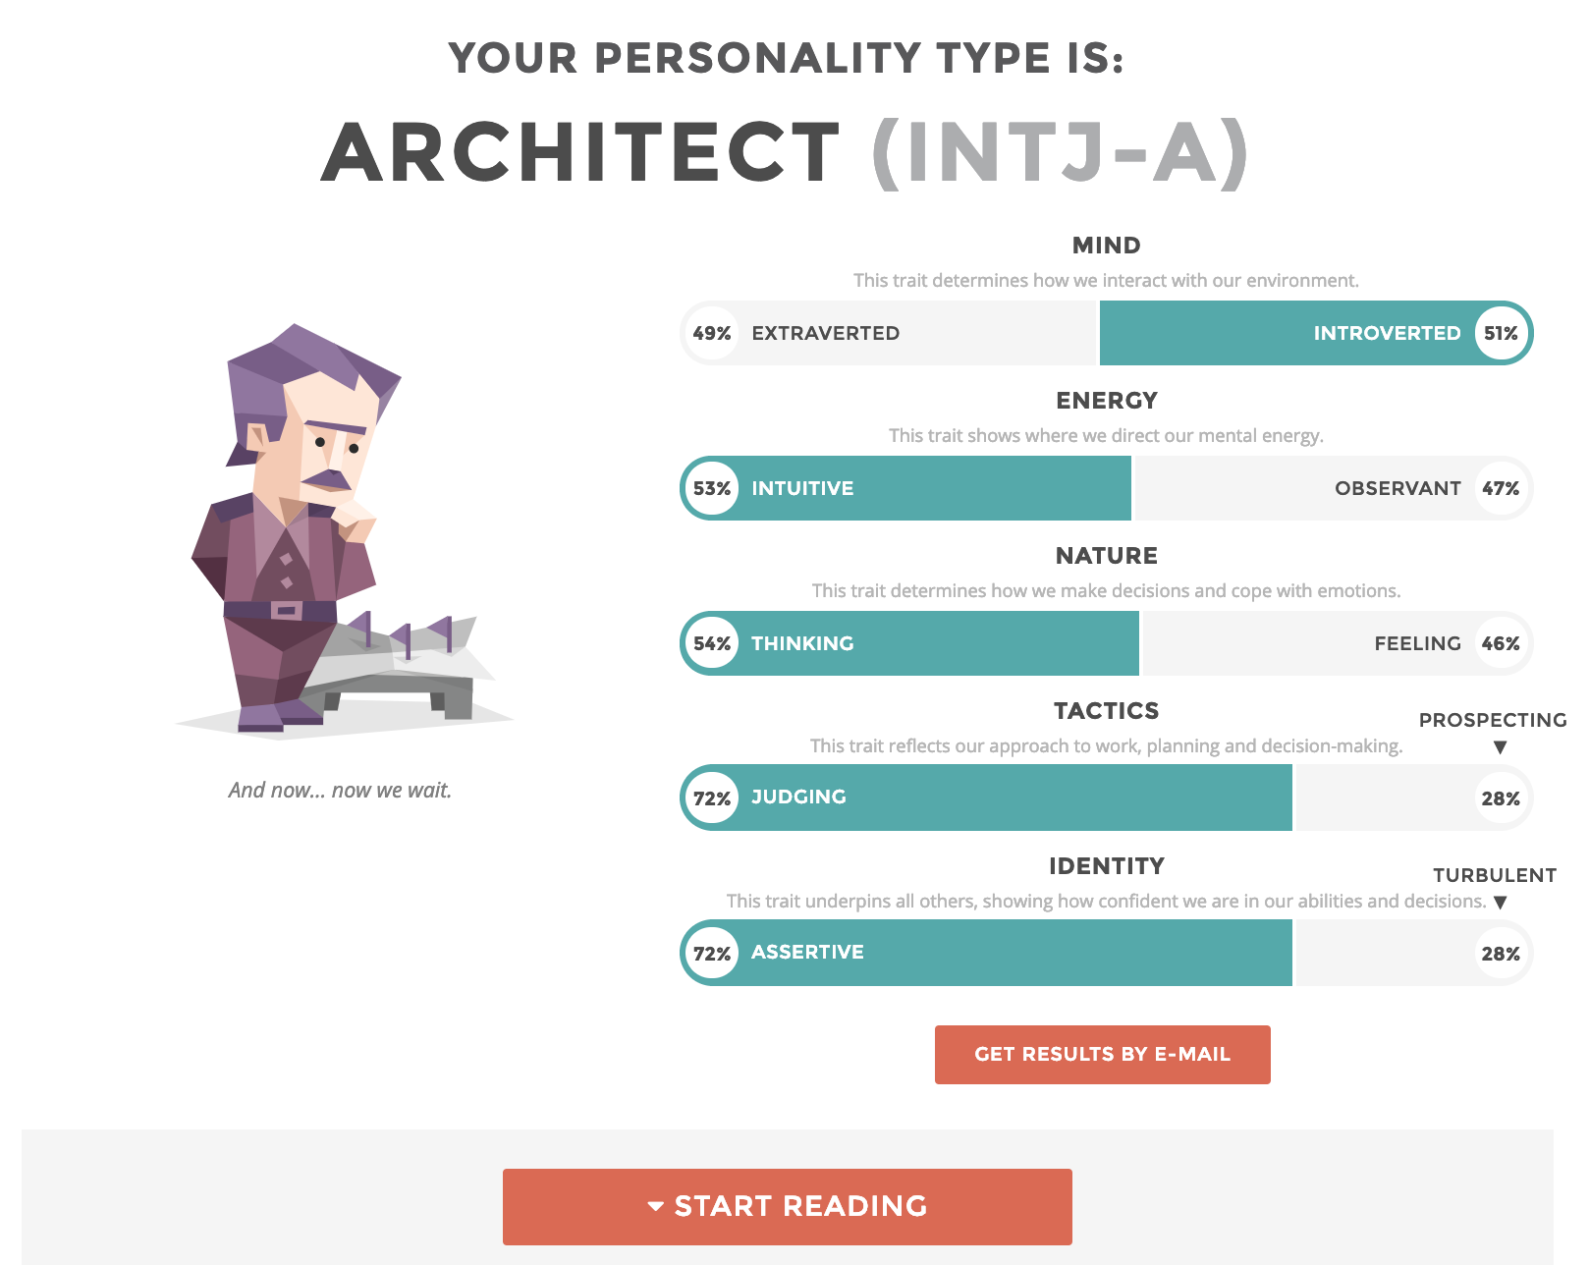

Visual representation of results use percentages for each category (mind, energy, nature, tactics, and identity).

Button to have results emailed.

After clicking “Get results by email” you can also tick a box to subscribe to their newsletter - potential idea for Qeesi.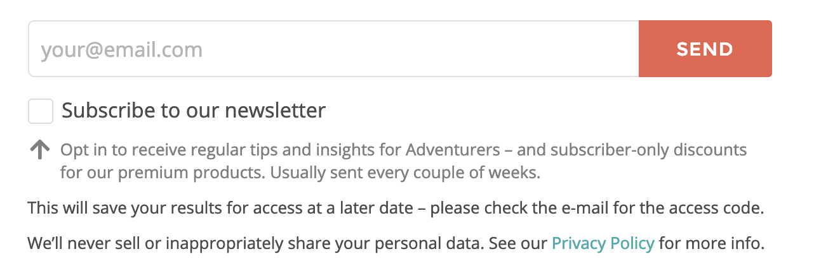

**Qualtics**

*Background*

“Qualtrics makes sophisticated research simple and empowers users to capture customer, product, brand & employee experience insights in one place.” Founded in 2002.

*Observations*

Login with UT EID

Different surveys for different needs (Research Core, Product Experience, and Brand Experience). Can create a survey from scratch, create from an existing survey, or use templates.

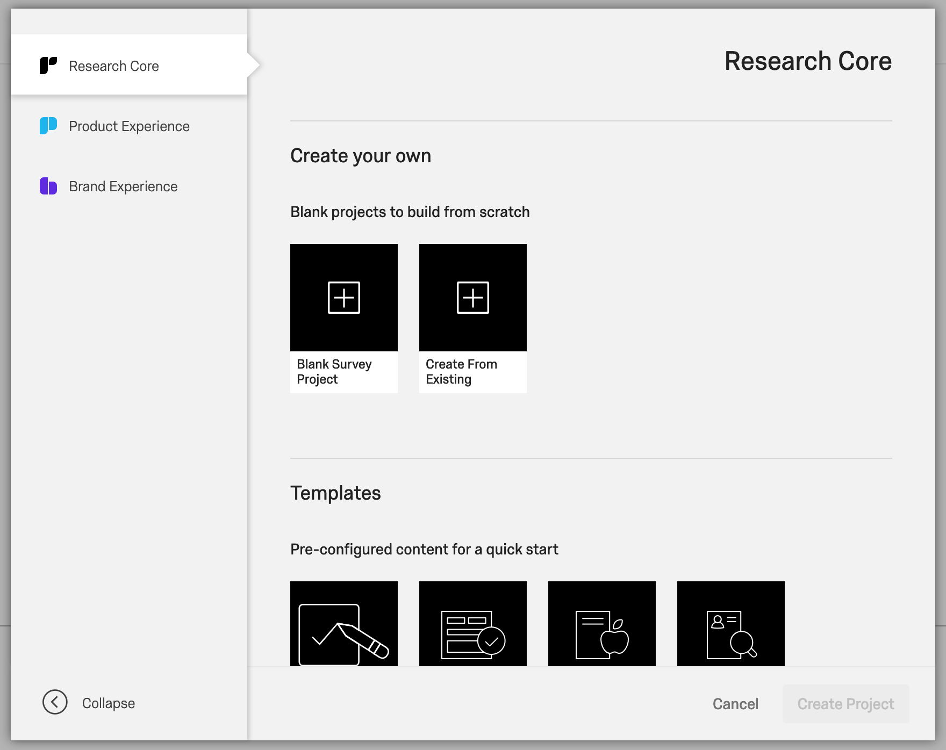

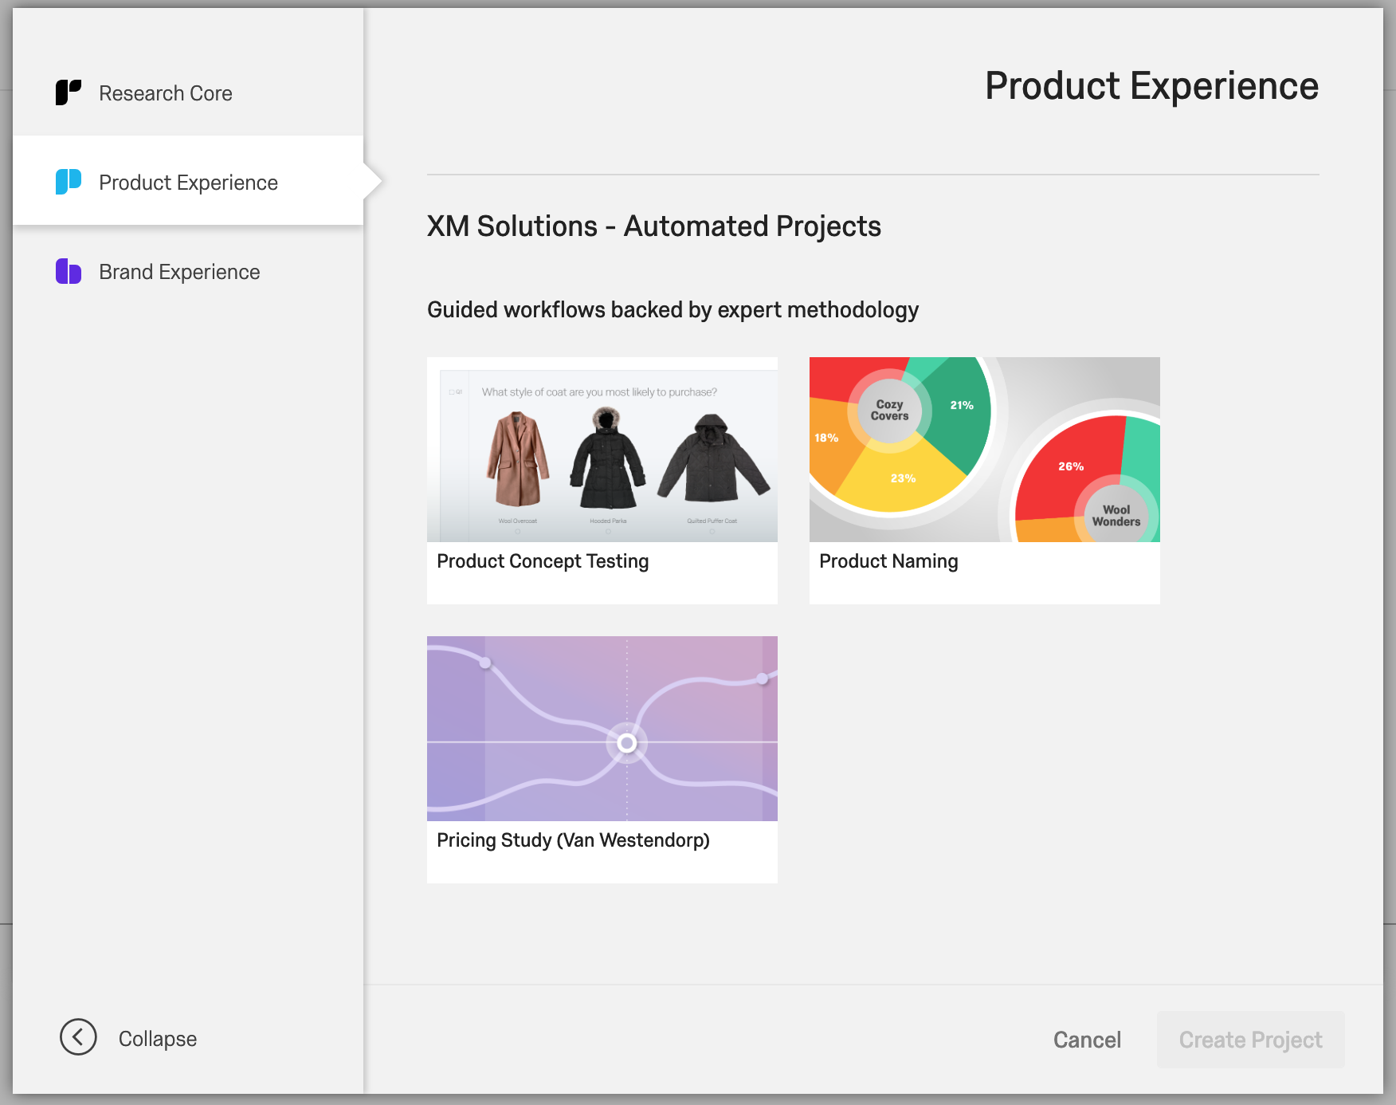

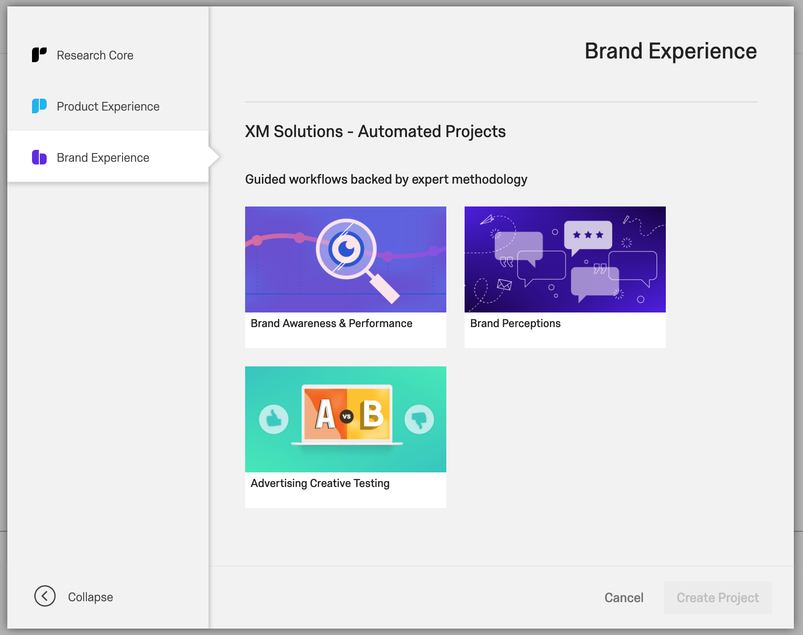

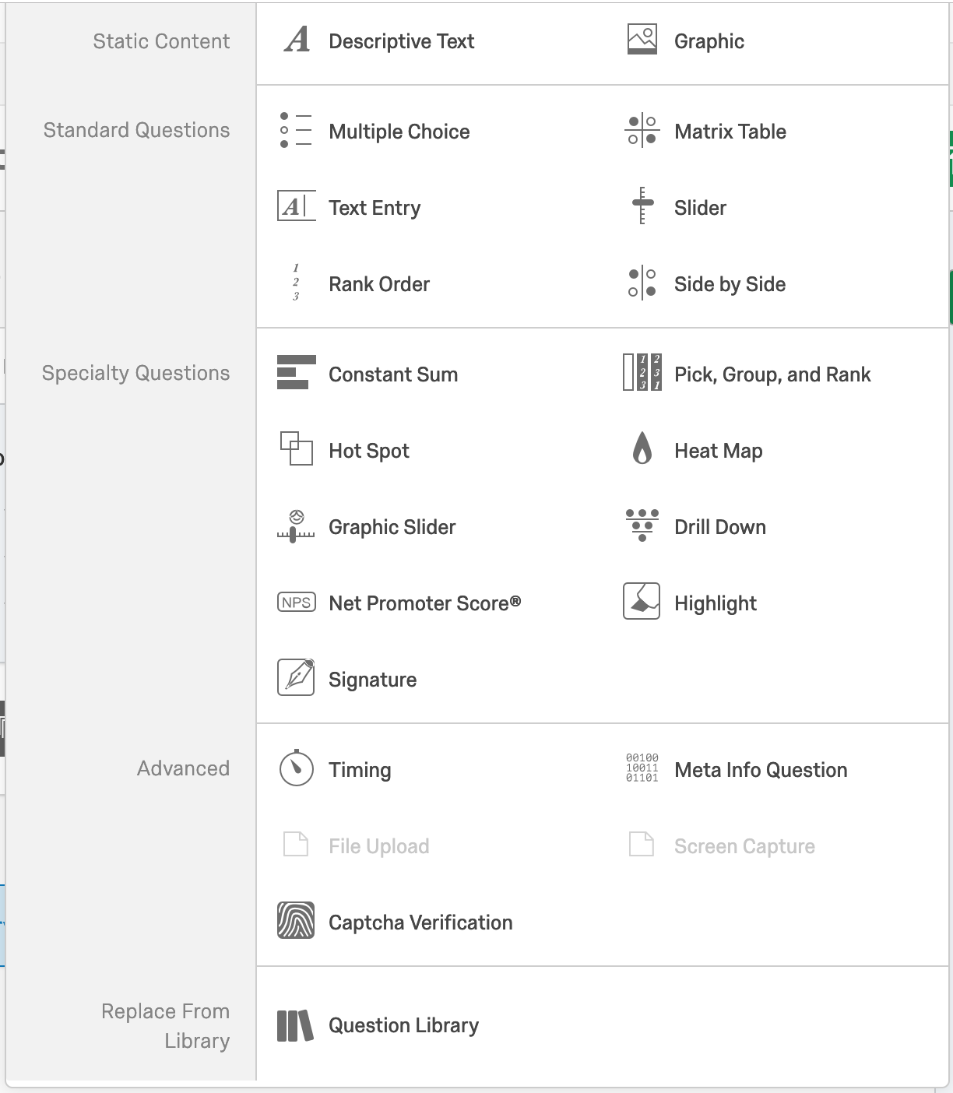

A lot of question types

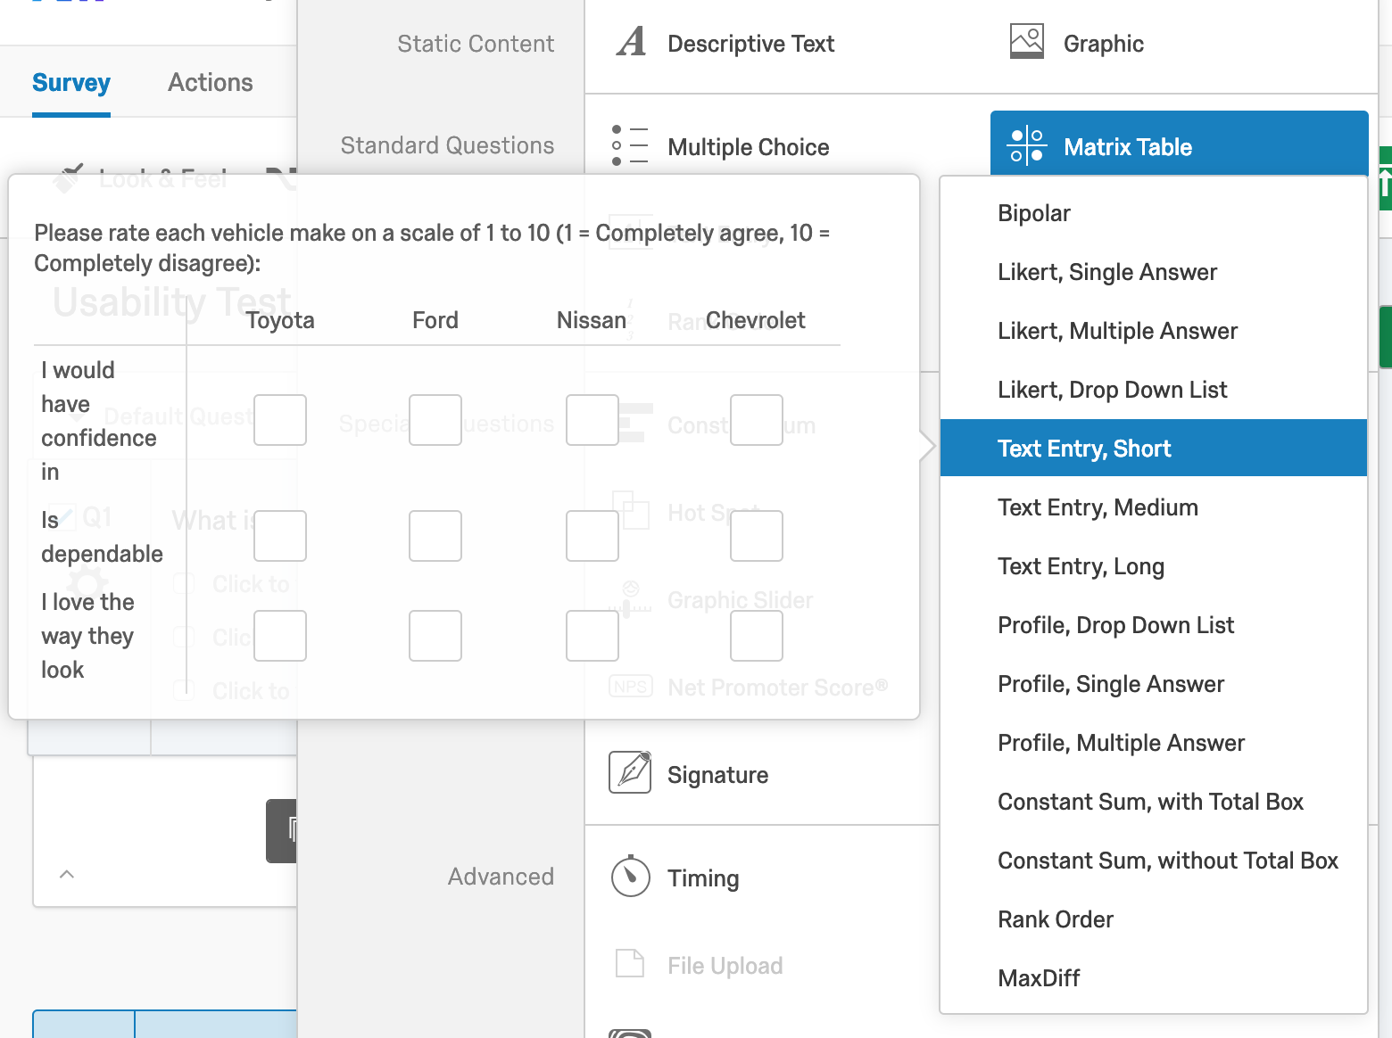

Categories within each question type

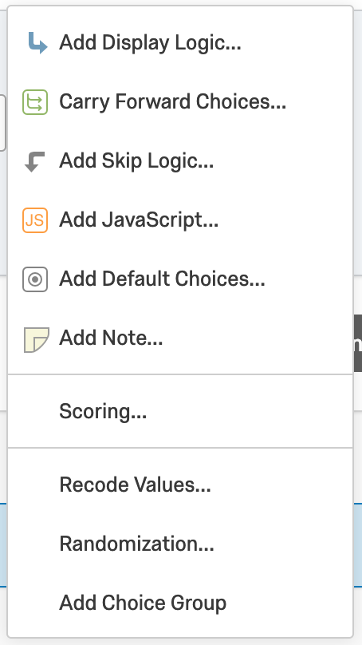

Able to add Skip Logic - this might be good for certain Qeesi responses

Can randomize the order of the choices

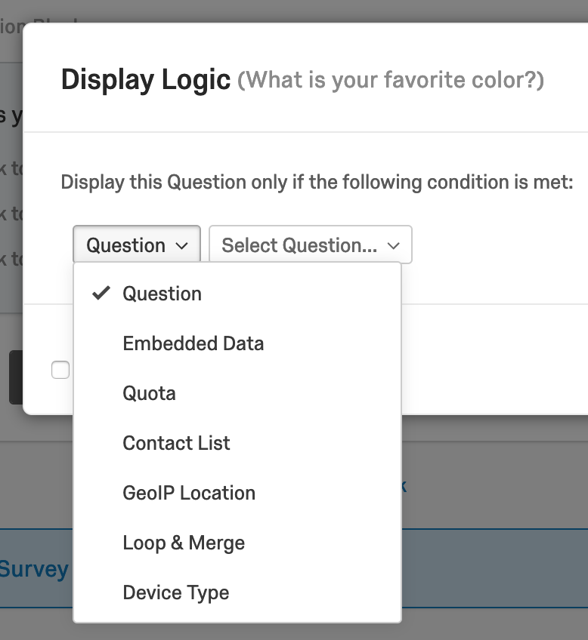

Display Logic options - don’t think this is necessary for Qeesi

**Retirement calculator (Fidelity, Vanguard)**

**Survey Monkey**